 ** **

**Football Should be Fun!**

**RAMSBURY FOOTBALL CLUB NEWSLETTER**

**DECEMBER 2022**

**135 Years of Football in the Community**

Established 1887

**Dear Parents, Guardians and all involved with Ramsbury Football Club,**

2022 has been another challenging year for everyone, but Ramsbury FC continues to thrive despite the challenges faced. This year, the 135th year since the club was formed, we have continued to manage 10 youth teams, a men’s team and a fantastic 40 strong Under 6s Development Squad. Ramsbury FC has never been as strong as it is now and the key reasons for this are the ongoing support and sponsorship we receive and the selfless volunteering and committed engagement by everyone involved with the Club that affords a fantastic sense of community and a real sense of achievement. All of us involved with Ramsbury FC appreciate this and wish you all a very happy festive break and all the very best for 2023. **Ramsbury FC Committee** R

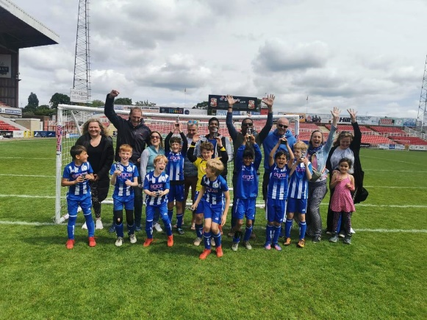 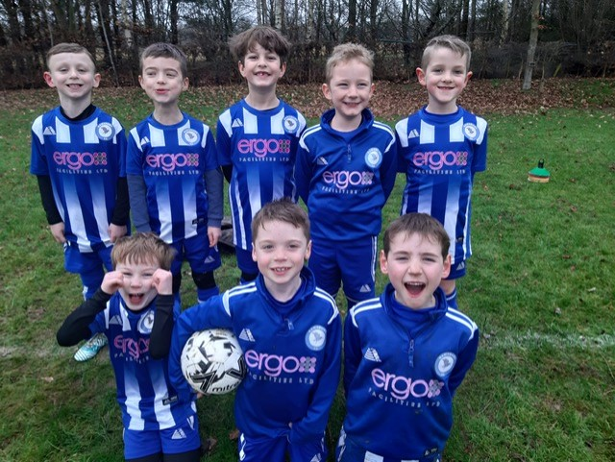

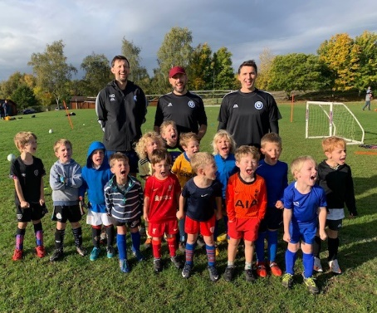 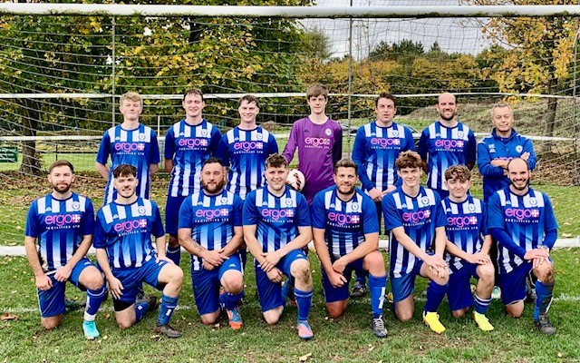 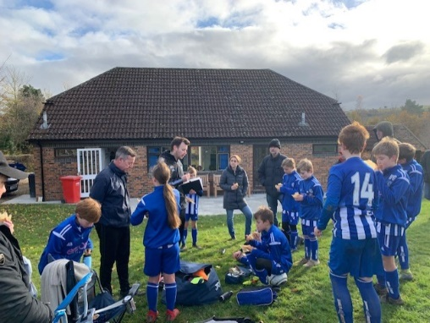

What makes this Club so special is its sense of community, fantastic facilities and the best bacon butties in the League! (Fairford FC Mum – November 2022).

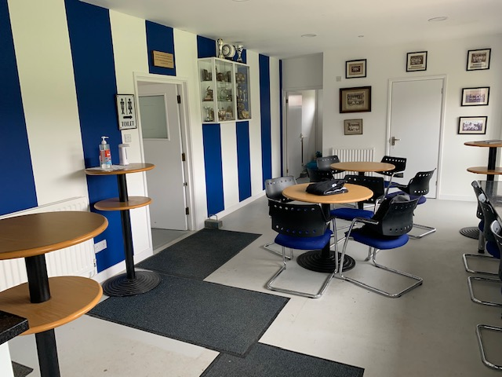**RAMSBURY FC CLUBHOUSE CAFÉ**

Ramsbury FC, in partnership with our club sponsor Ergo FM, have provided a clubhouse to be proud of and the envy of many other clubs.

There is still things to do and improve and in 2023 the Club will look to replace windows, add some needed shelving in the store room and look to refresh the club signage.

The Clubhouse Café has been a huge success and will only continue to be so with more volunteers. We have a very social crew and if you can spare a Saturday or Sunday morning once a month then contact Jon Symon or Fi Cresswell to volunteer for the rota. We will show you the ropes, provide tea or coffee and a bacon butty!

A big shout out to Bee Curtis who keeps our club so clean and tidy and who does such an amazing job!

**Ramsbury FC Player of the Year Euan Mulholland (Winner of the Oli Kimber Cup) has a memorable trip to see Manchester United!**

Euan Mulholland was the deserved recipient of the Olly Kimber Cup as the Ramsbury FC Player of the Year. This award is awarded to the player who best epitomises the ethos of Ramsbury FC and who has contributed to our reputation and success.

Euan was presented the trophy and two VIP tickets for the Manchester United v West Ham United match that included a meal and drinks. Euan took his dad on the trip to Old Trafford and was joined by the U10 Whites Coach Bash Miah and his son Louis who already had tickets, but were upgraded for the day.

All tickets were kindly provided by Alistair Collis who was the Under 6s lead coach last year and who made the fantastic experience for both boys and their dads possible. A huge thank you to Alistair and also to our Chair Andy Knowles for help make the day happen.

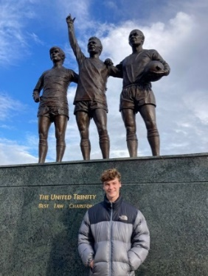 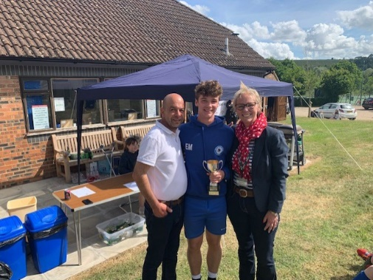 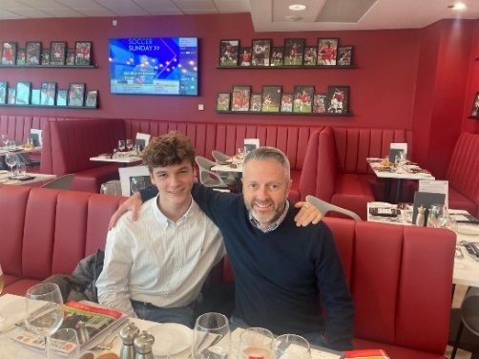 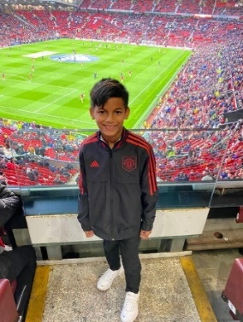

**DO YOU KNOW YOUR TEAM COACHES OR CLUB OFFICIALS?** 

**Under 6s Team Coaches**: Jon Symon (Level 1 Coach, Club Welfare Officer (CWO) and Secretary), Dan Creed (FA Playmaker), Hamish Gary (FA Playmaker), Chris Roberts (Level 1 Coach, Vice Chair, CWO and Men’s team Captain, Leigh Harris, Jon Hollick, Sam Cave-Penney & George Radulescu.

**Under 7s Team Coaches:** Ben Green (FA Playmaker), Chris Ainsworth (Level 1 Coach), Jack Paravicini (FA Playmaker), James Walton, Chloe Martin (Team Secretary).

**Under 8s Team Coaches**: James Underwood (Level 2 Coach), Ian Cresswell (Level 1 Coach), Matt Thomas, Fi Cresswell (FA Playmaker).

**Under 9s Team Coaches:**

**U9 Whites:** Steve Taylor (Level 1 Coach), Pete Wheeler (FA Playmaker), Fi Cresswell (FA Playmaker), Sean Maye (FA Playmaker).

**U9 Blues:** Laurence Mitchell (Level 1 Coach), Ray Foard (FA Playmaker), Simon Fellows (FA Playmaker), Will Beattie (FA Playmaker), Shelly Baverstock-Seaman (Team Secretary).

**Under 10s Team Coaches**:

**U10 (White):** Bash Miah (FA Playmaker), Ian Mundy, Dougal Watts, Glen Aylett (Team Secretary)

**U10 (Blue):** Rupert Harrison (FA Playmaker), Rob Green (FA Playmaker), Al Wade (FA Playmaker), Mark Bevan (Team Secretary).

**Under 11s Team Coaches**: Dan Beck (Level 1 Coach), Ronnie Stretch (Level 1 Coach), Matt Crame (FA Playmaker), Bryony Beck (Team Secretary).

**Under 12s Team Coaches**: Olly Scott Harden (FA Playmaker), Si Bartholomew (FA Playmaker).

**Under 13s Team Coaches**: Rich Gillard (Level 1 Coach), Adam Blanchford (FA Playmaker), Adrian Fisher.

**Under 14s Coaches**: Rob James (Level 1 Coach), James Collister.

**Senior Team Coaches**: Sean Eviil and Chris Roberts (Level 1 Coach, Vice Chair & Club Welfare Officer (CWO))

**Club Chair:** Andy Knowles

**Club Treasurer**: Katie Smith

**Club Secretary**: Jon Symon

**Club Welfare Officers**: Jon Symon and Chris Roberts

**Club Grounds & Maintenance**: Geoff Pratt

**Clubhouse Café Coordinators**: Fi Creswell & Jon Symon

**Club Sponsor**: Arthur & Karen Carrington: Ergo FM

**Christmas Drinks and a Curry for Ramsbury FC Volunteers**

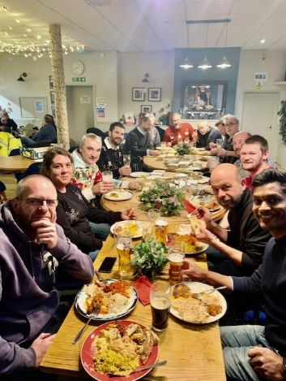Ramsbury FC Coaches, helpers and committee members enjoyed a great night out in the Ramsbury Royal British Legion (RBL) on Wed 7th December. The function was arranged to thank all volunteers for their commitment and fantastic support throughout the year.

The curry was provided by [Ruchi Indian Restaurant](https://ruchiindianrestaurant-sn1.co.uk/) in Old Town Swindon and once again was delivered by Bash Miah, the U10 Whites Coach, from his family’s restaurant. The food was simply outstanding and was ranged to suit all tastes from mild meat and vegetarian curries for the wusses to medium range to the spicily hot for the hard core; and it was all washed down with plenty of drinks courtesy of Ramsbury FC. A huge thanks to Marion and all at the RBL who hosted our event brilliantly. The RBL is a super café and bar – go and make use of it!

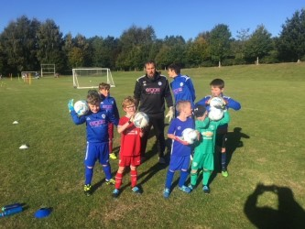**Goalkeeping Training with Geoff & Ben Pratt**

We are fortunate as a grass roots football club to have a superb Goalkeeping Coach and Geoff Pratt along with his son Ben has yet again provided some outstanding sessions.

All sessions were a huge hit and Geoff plans to hold more training in 2023 in between managing his committee role as the lead for all grounds and maintenance.

Well done Geoff and we will announce the next sessions once known.

**Automated Emergency Defibrillator (AED) for Ramsbury FC**

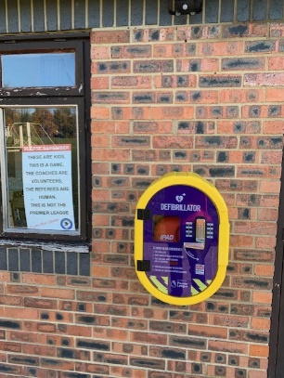 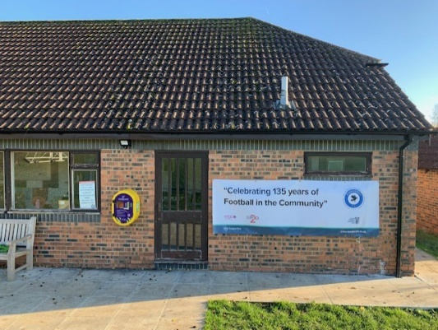 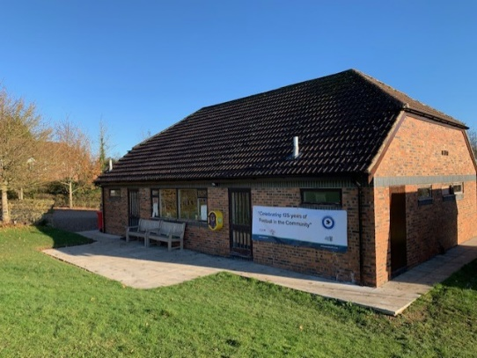

The Automated Emergency Defibrillator (AED) for Ramsbury FC was arranged by our Vice Chair, Coach and men’s team Captain Chris Roberts and has now been securely fitted courtesy of our club sponsor Ergo FM. The AED is an amazing addition to the AEDs already located by Mill Lane and at the Tennis Club and can be accessed by calling any Ramsbury FC Coach. Although most of our coaches are fully trained in First Aid and using the AED, it is a very simple and easy device to use and can be a life saver if faced with Sudden Cardiac Arrest (SCA). **This link provides a useful guide of how to use an AED**: [Automated External Defibrillators - Red Heart Association](https://redheartassociation.com/lesson/automated-external-defibrillators/)

**Best Dressed in Wiltshire - Ramsbury FC Online Shop**

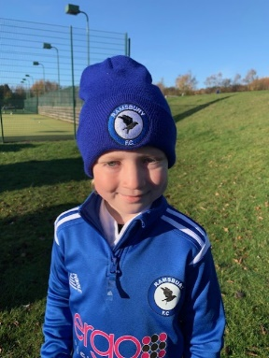 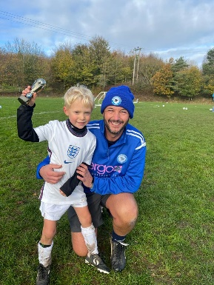 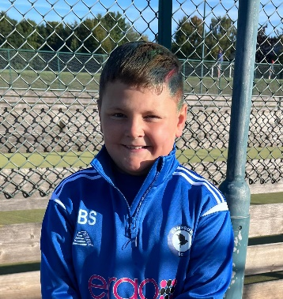 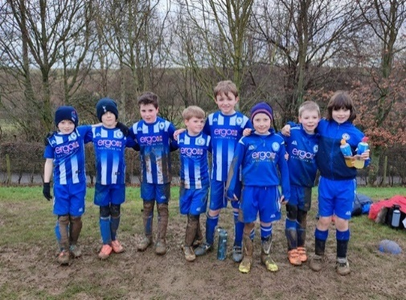

All Ramsbury FC players and coaches continue to look fabulous in their distinctive Ramsbury FC / Ergo FM branded strips, tracksuit tops, beanies and hoodies. There is so much more now on offer in our online shop so go and have a browse; and we will also have some items on display so you can feel the quality. All items purchased provide a rebate to the club for future investment!

The Ramsbury FC online shop is accessed via the Ramsbury FC web site [www.ramsburyfc.co.uk](http://www.ramsburyfc.co.uk) or via our partners Pendle Sportswear: [Products for Ramsbury FC (pendlesportswear.co.uk)](https://ramsbury-fc.pendlesportswear.co.uk/replica-products/football-training-wear/)

**Ramsbury FC Longest Serving Youth Players Recognised**

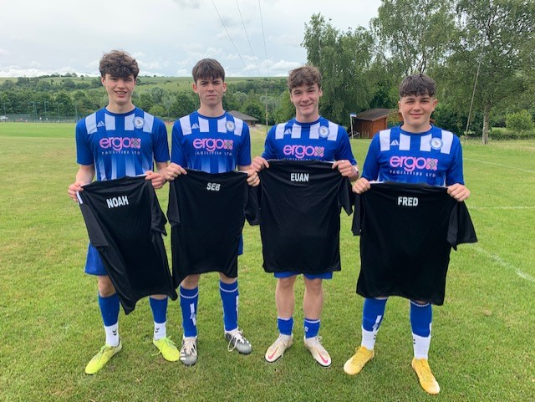Noah Greenway, Euan Mulholland, Sebastian Symon and Freddie Knowles from Ramsbury FC U17/18s were presented with personalised shirts as they played their last match for Ramsbury FC earlier in the year.

All four players have been with the Club for over 10 years and were stalwart members of the U16s team that never lost a match and were crowned Mid Wilts U16s Red Champions.

Noah and Euan have joined the Ramsbury FC men’s team along with Ben Pratt and Byron Gale; and Freddie has joined MYFC U18s for his last season in youth football. Sebastian has taken a break from football and is honing his skills as sous chef in Rick Stein’s Marlborough while also studying for his A levels.

All four players have been a credit to their families and coaches and are wished the very best with their A Levels and future careers.

 **WE NEED YOU TO SUPPORT YOUR FOOTBALL CLUB** 

**YOUR CLUBHOUSE NEEDS YOU! Volunteers are needed to help in our superb Clubhouse Café on Saturday and Sunday mornings and if you or your friends or family are able to help then please pop into see the Clubhouse Café Crew or contact Jon at** [**jonthansymon@hotmail.com**](mailto:jonthansymon@hotmail.com) **or contact us through the Club web site at** [**www.RamsburyFC.co.uk**](http://www.RamsburyFC.co.uk)

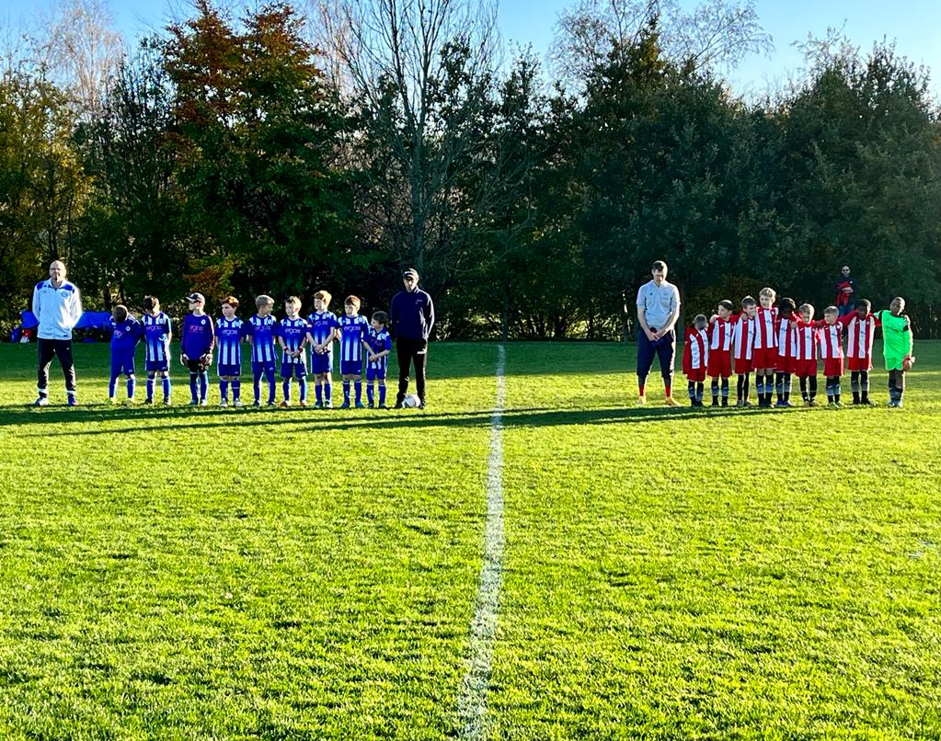**We Remembered Them – Remembrance Day 2022**

All our teams paid their respect for those Servicemen and women who died in conflict and wars to preserve the peace we have today.

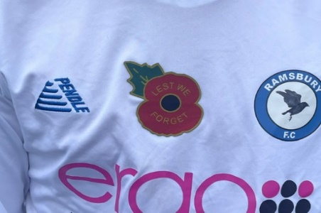**Pictured**: Ramsbury FC U9 Whites

**SAFEGUARDING CHILDREN IS THE PRIORITY FOR RAMSBURY FC**

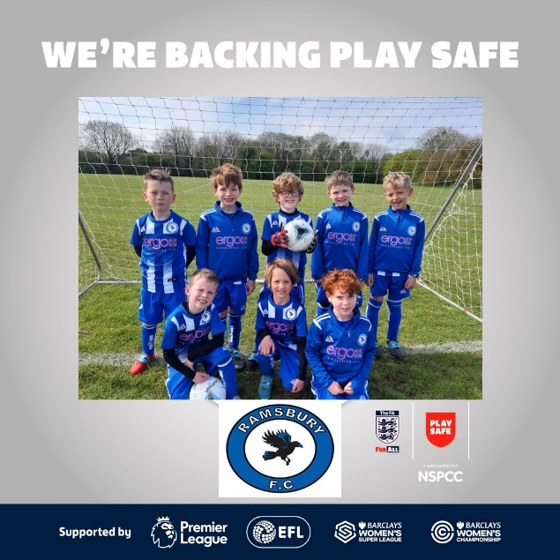Ramsbury FC is fully supporting both Wiltshire FA and the North Wilts Youth Football League initiative in getting all coaches fully qualified and ensuring parents remain on site when children are training and playing matches.

All Ramsbury FC Coaches and Assistant Coaches have completed the mandated Safeguarding Children Course and four of our coaches have completed their Level 1 Intro to Coaching Course and another coach is well on their way to completing the UEFA C License coaching qualification.

It is important that all coaches complete the mandated courses and particularly Safeguarding and First Aid.

It is also equally important that all parents assist the coaches and team managers by staying on site when training is on and during matches as this is very much in line with Club, League and FA policy.

**Help to Keep Your Children Safe and Back Play Safe!**

If you want to contact Ramsbury FC about joining or if you have a query or concern then please do so via our web site: [www.ramsburyfc.co.uk](http://www.ramsburyfc.co.uk) all messages go direct to the Club Secretary.