

**RAMSBURY FOOTBALL CLUB NEWSLETTER **

Established 1887

**Aug 2021**

**Dear Parents, Guardians and all involved with Ramsbury Football Club,**

**It has been a while since our last Club Newsletter in January as we all have continued to deal with the challenges faced with the COVID pandemic and for many the significant loss of family and loved ones**. Hopefully the worst is behind us and we can look forward to a degree of normality and community activity.

Throughout the last 18 months or so Ramsbury FC has tried its best to stay connected with all parents, guardians, players and all those involved with the Club; and the Club has provided training and matches when permitted, reduced fees to compensate for disrupted seasons and took time to congratulate players, coaches and teams for their many successes achieved during a very challenging period. Indeed, it has been amazing what has been achieved and the Club Committee have done an amazing job and so have you all who have stayed loyal and committed to our fantastic grass roots village football club – achieved through genuinely inspiring community spirit, mutual support and a love of football and outdoor activities.

You will all be glad to know that Ramsbury FC achieved affiliation with the Wiltshire FA and have teams and players registered in both the North Wiltshire and Mid Wiltshire Leagues. We have over 150 players registered with the Club and another 30 or so hopefully joining before the season commences on 5 Sep 21.

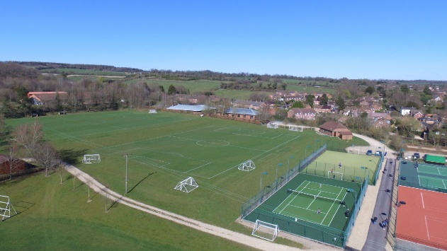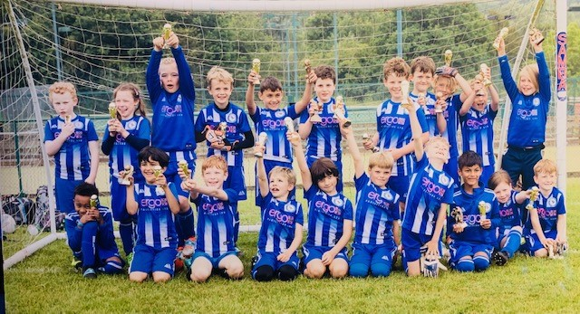Well done to all those parents and guardians for completing the Club Registration Form, paying subscriptions fees and ensuring all the new FA registration requirements of photos, email addresses and parent/guardian personal information was provided to be able to register our players. It was a big ask and took a lot of work to ensure the requirements were met, but we got there in the end and the Club Committee is very grateful for all your support to help achieve this.

**Finally**, a huge thank you to all of the Club Committee, helpers, parents and guardians and players for making the Ramsbury FC Festival of Football and Awards Ceremony in June a huge success! 23 teams played over 54 games on an overcast but relatively rain free day and saw some excellent football played. The Bar and BBQ run by Bryony Beck and her merry band of volunteers was a huge success and the Awards Ceremony saw a fond farewell to Nicola and Chris Allen and Club awards to the U16s, for Team of the Year, Chris Allen as Coach of the Year and Lucas Pottinger in the U12s for winning the prestigious Oli Kimber Cup and Player of the Year. However, the real winner was Ramsbury FC as it continues to flourish and develop carefully and positively within a Community that genuinely cares and only wants *football to be fun*.

**Jon Symon**

**Club Secretary**

**Ramsbury FC U6s Development Squad has a new Head Coach**

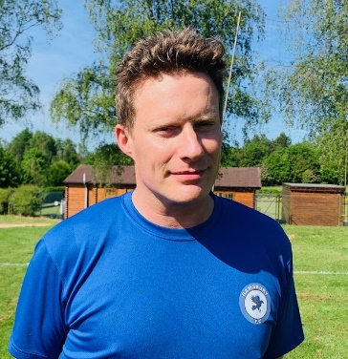Many of you will know that after 2 successful seasons as the U6s Head Coach, Al McKay has stepped down. Al did a great job and is thanked for his commitment and drive in developing a strong U6 squad and getting many players in a great position to transition into the U7s Team. He will continue to support the Club and will likely be seen at weekends supporting his son in the U8s team.

Al is no stranger to the U6s as he and Ned Llewellyn have assisted Al and are familiar with what is required. This season Al will be ably supported by Fiona Cresswell, a qualified FA Playmaker Coach with the U7s and U8s (she is a glutton for punishment!), who will help Al with the administration. We wish Al and the team all the best for when they start training on Saturday mornings up on the top pitch at 0930-1030.

**Ramsbury FC U7s also have a New Coach!**

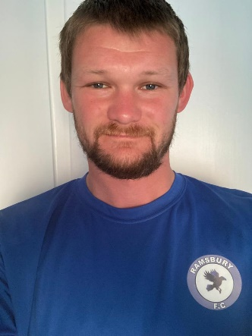James Underwood is the new Coach for the U7s Team and will be responsible for training, coaching and mentoring the U7 squad along with Ian and Fiona Cresswell and Matt Thomas for the 2021-2022 Season.

James is no stranger to Ramsbury FC as he is a first team player with the men’s team and has strong family ties with the village. His grandfather, Dave Rushen was a former player in the men’s team and a well-respected Chair of Ramsbury FC and so much so that the Dave Rushen Shield is presented annually for Coach of the Year!

James is a qualified FA Level 2 Coach, and the Club’s only Level 2 Coach, and as a School Teacher should be well placed to coach and develop our superb U7s Team.

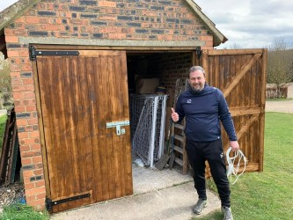**The Shed has a New Door at Last!**

With a very generous grant from the Ramsbury & Axford Parish Council we have at last fixed the doors to the Club Shed!

It has been a long time coming and those Coaches that know the combination and use it regularly are delighted that the new doors are not a risk to life or limb and are able to be locked effectively.

A huge thank you to Chris Roberts for liaising with the Parish Council and to ergo FM, our Club sponsor, for getting their tradesmen to do such a great job.



**Ramsbury FC has an Online Club Shop** Ramsbury FC has partnered with Pendle Sports Wear to provide a superb online Club Shop.

The Club Chair, Andy Knowles, has arranged that all purchases by coaches or parents or guardians will see a return provided to the Club for future investment. It is an excellent arrangement and already the quality of items available is being appreciated. Good job Andy!

The array of sports kit, shin cards and club branded clothing and sports bags etc can be found here:

[Ramsbury FC Club Shop (pendlesportswear.co.uk)](https://ramsbury-fc.pendlesportswear.co.uk/)

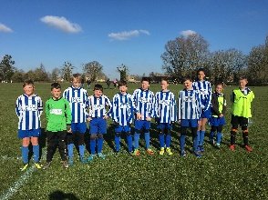 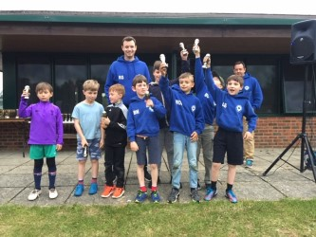 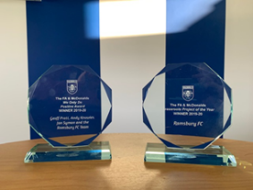 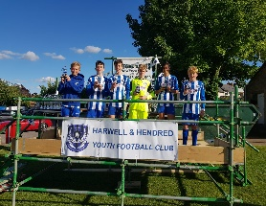 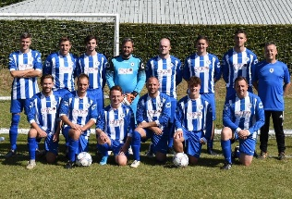

**DO YOU KNOW YOUR TEAM COACHES AND CLUB OFFICIALS?** 

**Under 6s Team Coaches**: Al Collis, Ned Llewellyn and Fiona Cresswell (FA Playmaker).

**Under 7s Team Coaches**: James Underwood (Level 2 Coach), Ian and Fiona Cresswell, Matt Thomas.

**Under 8s Team Coaches**: Steve Taylor (FA Playmaker), J-P Degouve de Nunques (FA Playmaker).

**Under 9s Team Coaches**: **Whites**: Bash Miah (FA Playmaker), Matt Ilott (FA Playmaker).

**Blues:** Nicky Place (FA Playmaker), Rob Green (FA Playmaker).

**Under 10s Team Coaches**: Dan Beck (Level 1 Coach) and Matt Crame (FA Playmaker).

**Under 11s Team Coaches**: Olly Scott-Harden (FA Playmaker), Simon Bartholomew FA Playmaker).

**Under 12s Team Coaches**: Rich Gillard (Level 1 Coach), Adam Blanchard (FA Playmaker), Adrian Fisher.

**Under 13s Team Coaches**: James Collister, Sonny Bathe (Level 1 Coach), Rob James (FA Playmaker).

**Under 16s Coaches**: Mark Savory (Level 1 Coach), Rich Englefield (Level 1 Coach), Harrison Yates (GK Coach, FA Playmaker), Nigel Hawkins.

**Under 17s Coaches**: Geoff Pratt (Level 1 Coach), Andy Knowles (FA Playmaker).

**Senior Team Coaches**: Sean Eviil and Chris Roberts.

**Club Chair**: Andy Knowles **Vice Chair**: Chris Roberts **Treasurer**: Bryony Beck **Secretary**: Jon Symon

**Covid Officer**: Jon Symon **Club Welfare Officers (CWOs):** Jon Symon and Chris Roberts

**Have a look at our web site:** [http://www.ramsburyfc.co.uk/](https://nam12.safelinks.protection.outlook.com/?url=http%3A%2F%2Fwww.ramsburyfc.co.uk%2F&data=02%7C01%7C%7C2162935440874f4a161408d74c0eb1d9%7C84df9e7fe9f640afb435aaaaaaaaaaaa%7C1%7C0%7C637061498303983689&sdata=O7beFgq7dQJaCyVSgVbZAzLiHCwTrPypW%2F4b%2FFut4lg%3D&reserved=0)

**DO YOU KNOW YOUR CLUB WELFARE OFFICERS?** 

**Jon Symon and Chris Roberts are your Club Welfare Officers. We are there to help!**

**Safeguarding** children and young players within Ramsbury FC remains paramount and all qualified Coaches are both First Aid and Safeguarding trained. This is mandated by the FA and critical for attaining Chartered Standard status. PLEASE do feel free to discuss any issues you may have concerning safety or safeguarding with your coaches or one of the Club Welfare Officers. Ramsbury FC also has policies on Child Protection and Code of Conduct that can be found at our website: [http://www.ramsburyfc.co.uk/](https://nam12.safelinks.protection.outlook.com/?url=http%3A%2F%2Fwww.ramsburyfc.co.uk%2F&data=02%7C01%7C%7C2162935440874f4a161408d74c0eb1d9%7C84df9e7fe9f640afb435aaaaaaaaaaaa%7C1%7C0%7C637061498303983689&sdata=O7beFgq7dQJaCyVSgVbZAzLiHCwTrPypW%2F4b%2FFut4lg%3D&reserved=0)

The FA also want all Clubs to make you aware that any adult or young person with urgent concerns can also ‘whistle-blow’ by calling 0800 169 1863 and asking for The FA safeguarding team, or via email on [safeguarding@TheFA.com](mailto:safeguarding@TheFA.com). Alternatively you can go direct the Police or Children’s Social Care and report your concerns there, or to the Child Protection in Sport Unit via [cpsu@nspcc.org.uk](mailto:cpsu@nspcc.org.uk) or the NSPCC Helpline via 0808 800 5000 or by emailing [help@nspcc.org.uk](mailto:help@nspcc.org.uk).

**Clubhouse Update**

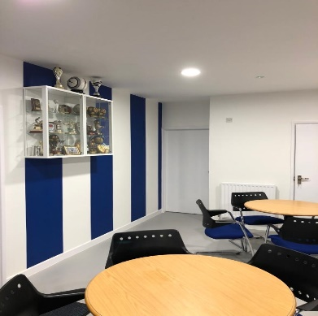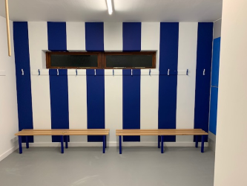Hopefully you will all have visited the Clubhouse over the last year, even if only to use the hugely improved toilets, and seen the stunning refurbishment courtesy of our club sponsor Ergo Facilities Management.

The difference it has made to the Club has been amazing and it has certainly made it more welcoming and a much nicer place to get out of the wind and the rain when the weather is poor (too often this Summer unfortunately!).

The back of house has also been completed now with only the patio to be upgraded to make our Clubhouse as good as it can be for you all. **We now just need volunteers to help manage it and run it on Saturday and Sunday mornings to provide sweets, hot and cold drinks and bacon butties! It is not an onerous task and all volunteers would be welcomed. Please contact Jon Symon or Bryony Beck.**

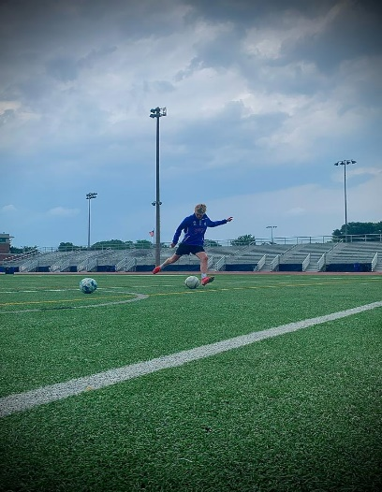**A Fond Farewell**

The U16s, to be U17s had a great 20/21 season not only winning a prestigious Wilts FA award, but also winning the Ramsbury FC Team of the Year for going all season unbeaten in the League and for winning the Mid Wilts U16s Red Division! Integral to that success was the team Captain Joe Bates who as a no nonsense CDM was a catalyst for much of the success of the team. Joe’s dad is in the Army and has been posted back to the USA and Joe and the family have returned as well. It is a great loss to the team, but Joe (pictured training in the USA…in his Ramsbury FC training top (of course)) is continuing to play ‘soccer’ in the USA and the U17s are desperately hoping that a US Tour is on the cards? Keep dreaming U17s……!!!!! In addition to Joe, both Oli and Emil Flach have returned to their mum’s native country of Norway and will be equally missed. Both the twins are excellent players with Oli winning most improved last season. Both the Flach and Bates families are wished the very best!

We also say fond farewell to Nicola Allen and he husband Chris Allen who depart for a life in Devon and we look forward to the beach football invite! Oliver Bond has called time on coaching with the U15s, to be U16s next season, and we wish him, Tristan and his family all the best. Martin Greenaway who was a coach with the U9s/U10s, who will be the U11s, has also left and Al McKay has stood down as he hands over the U6s to Al Collis. A huge thanks to all of you all for your time, commitment and achievements.

 **WE NEED YOU TO SUPPORT YOUR FOOTBALL CLUB** 

**Volunteers are needed to help run the Clubhouse Café on Saturday / Sunday mornings and if you or your friends or family are able to help please contact Jon Symon** [**jonathansymon@hotmail.com**](mailto:jonathansymon@hotmail.com)

**We also need parent volunteers to help with car park marshalling on match days, especially when multiple teams are playing Home games, and you can just volunteer through team coaches.**