RAMSBURY FOOTBALL CLUB
(First Established 1887)
“A family friendly FA Chartered Football Club in your community with qualified coaches, great clubhouse facilities and competitive football played in a safe and inclusive environment”
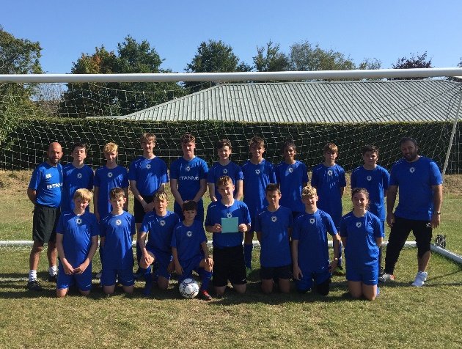
Key Information
Club Location | Recreation Ground, Hilldrop Lane, RAMSBURY, SN8 2RB
Age Groups | U6,U7,U8,U9,U10,U11,U12,U15,U16s  (Both Boys and Girls)
Registration | Through team coaches using Club form
Training | Friday evenings or Saturday mornings
Costs  Our aim is to keep grass roots football affordable! | £90 season fee  (£80 if paid before  1 Oct )  £45 for U6s (£35 if paid by 1 Oct) | Covers all games; training, pitches, insurance & referee fees – no additional costs | Includes use of MUGA and free futsal 5-a-side sessions in Swindon (subject to availability)
Kit | Club provided or through parent contributions or sponsorship |  | * U7s kit bought annually by the club
Ramsbury FC Web Site – ramsburyfc.co.uk
Contact us through the Ramsbury FC Web Site

