

**RAMSBURY FOOTBALL CLUB NEWSLETTER **

Established 1887

January 2021

**Dear Parents, guardians and all involved with Ramsbury Football Club,**

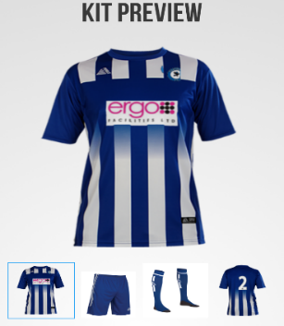Yet again our season has been disrupted due to COVID and we find ourselves in a national lock down. I am sure all the coaches informed you of the FA decision to halt grass roots football, in line with Government direction, and when we know the date we can return playing we will let you know. Until then, Ramsbury FC will remain closed and our thoughts are with all those who have suffered illness or loss or are working on the front line doing their best to defeat COVID. Stay safe all of you.

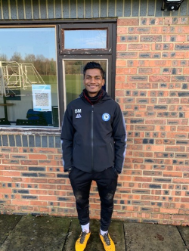**Ramsbury FC Continues to Flourish**

We now have over 220 players in our 11 youth teams including a fantastic 30 strong under 6s Development Squad, 30 strong senior team and an under 12s team who are unbeaten and top of their Division. We have attracted 17 fantastic new coaches, provided all teams with new kit and training tops and have bought more goals and training equipment.

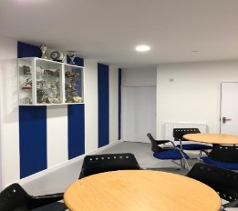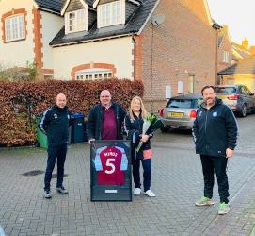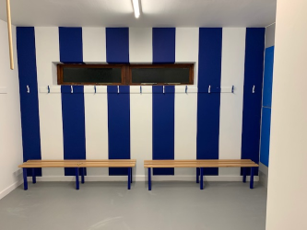Through the generosity of our sponsors and an anonymous donation made through the Ramsbury Recreation Centre, we have also been able to provide qualified coaches with a brand new all-weather jacket, as worn (above left) by Bash Miah one of the new U8 coaches. We have invested in equipment, a new web site and will soon complete Phase 2 work of the Clubhouse refurbishment. It has been a busy year and all involved have worked so hard to achieve our success.

**Key to this success has been our superb club sponsor Ergo FM** or to be precise Arthur and Karen Carrington. Arthur and Karen have been instrumental in the Clubhouse refurbishment and the purchase of team strips and training tops. Both continue to provide fantastic support and to show our appreciation Ramsbury FC presented a framed football shirt, signed by Tyrone Mings of Aston Villa and England (as shown above right). Arthur is a huge Aston Villa fan and our Chair Andy Knowles used all his contacts to get the shirt, worn and signed by Tyrone Mings, framed and presented to say thank you. They were both delighted with Karen telling Arthur it was not a gift to be displayed in the bedroom!

**Ramsbury Football Club Awarded FA Charter Standard for the 2020/2021 Season and Win Two Wiltshire FA Awards**

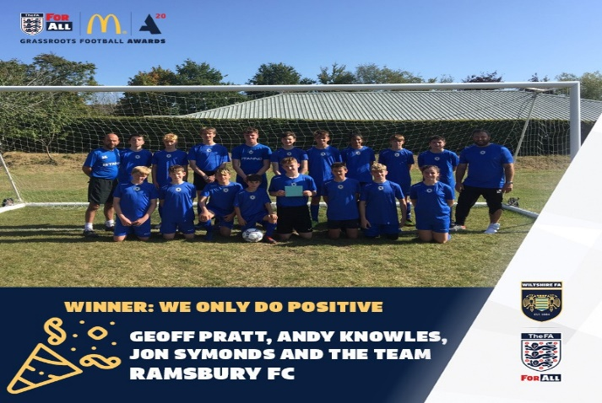Ramsbury FC has deservedly been awarded the FA Charter Standard for the 2020/2021 Season. It confirms that we continue to be a community grass roots football club that the FA recognises as upholding the highest standards. A great achievement and well done to all involved.

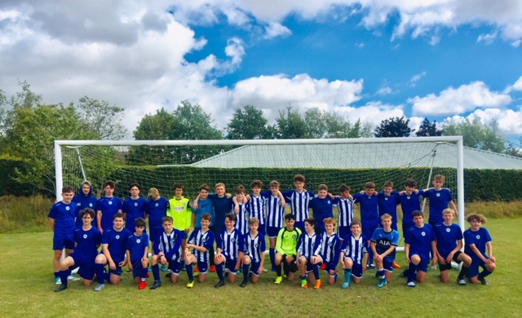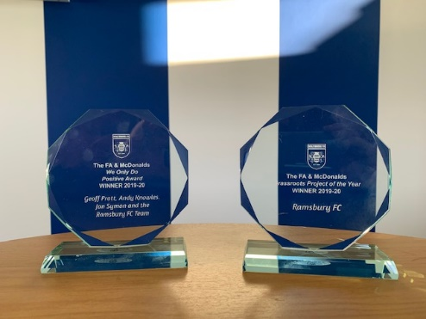Not only did we achieve the FA Charter Standard, but we were also nominated for two Wiltshire FA awards and I am delighted to say we were successful in both!

Our awards (as seen above) were for Club Project of the Year for our refurbishment of the Clubhouse and ‘We Only Do Positive’ for our Under 16s team for their fair play and team spirit. Great awards have been placed in the Clubhouse for all to see.

**Changes to Ramsbury FC Committee**

**There have been a couple of changes to the Club Committee**. After many years as Club Secretary Nicola Hickford has departed and has been replaced by Jon Symon. Nicola, along with husband Chris (Allen), has been instrumental in getting Ramsbury FC to the strong position it is in now and has put in years of hard work as Secretary and managing the Clubhouse. She is missed by us all and we wish her all the very best.

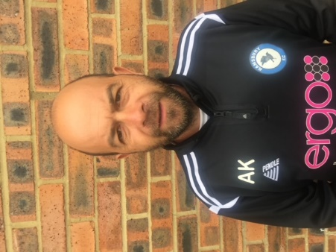**Bryony Beck has replaced Chris Allen as Treasurer**. Chris, like Nicola, has been a stalwart of Ramsbury FC and continues to be the lead Coach for the U7 and U8 teams and was responsible for attracting many new coaches to the Club. He has handed over the Treasurer role to Bryony who is well known to many in the community and husband Dan is the U9s Coach. Bryony is a great addition and we are delighted to have her on board.

**We also have a new(ish) Chair**. Andy Knowles (pictured right) is the Club Chair and also a Coach with the U16s team. Like Nicola and Chris, Andy has been with the Club for some time and has been instrumental in the Clubhouse refurbishment and in providing new jackets for all qualified coaches. He is a fervent Liverpool fan and has the added friction that fellow U16s coach, Geoff Pratt, is an Everton fan! To date there has been no red cards issued for either with the U16s unbeaten in the League and the Wiltshire Cup. Andy took over from Jon who is now the Club Secretary.

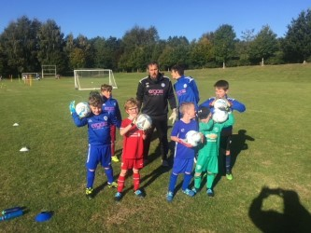**Goal Keeping Sessions for Youth Teams**

Earlier in the year Geoff Pratt, who is the U16s Coach, a senior team goalkeeper and a qualified goal keeping coach, provided a number of sessions for our goalkeepers across all age groups.

The sessions were really well attended, well received and great fun. Geoff plans to run more like this once we are all back playing and training post the lock down.

Great to see so many excellent young Goal Keepers!!!!

**Ramsbury & Axford Parish Council Provide Generous Grant to Ramsbury FC**

Club Vice Chair, Chris Roberts, received notification from the Ramsbury and Axford Parish Council Clerk, Carol Standage, that the Parish Council were pleased to award a generous grant to Ramsbury FC. The grant is very gratefully received and will be used to refurbish the storage shed doors next to the Clubhouse that have required repair for some time. A big thank you to Ramsbury & Axford Parish Council.

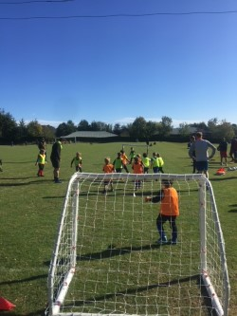**The Key Ingredients to a Successful Grass Roots Community Football Club**

Our wonderful Football Club is only as good as its constituent parts. It is a thriving community venture that relies on volunteer coaches and helpers and the unbridled enthusiasm of the boys and girls who play in our teams. Our 30 strong U6 Development squad has been an unqualified success and much praise should go to Al Mackay and Pete Wheeler and new coaches Ned Llewellyn and Alisdair Collis. They have done such a great job and their success can be seen (and heard) most Saturday mornings at the far end of the top pitch.

Equally successful has been our ever-improving junior teams and the 17 new coaches we have attracted to come and help train them. It has been a joy to watch them play, win or lose (but mainly win!), and they are a credit to you all. Most impressive has been the willingness of all coaches to take on all standard of players and improve them. This has also been brilliant to see and, again, is credit to all our wonderful coaches and helpers who have embraced the Club ethos and spirit.

**If You Need To Get In Touch Then Please Do………………………..**

If any parent, guardian or player wishes to get in touch with the club committee then there is a contact / message box on the Ramsbury FC web site. Just post the message and the Club Sec, who is also a Club Welfare Officer (CWO), will ensure your message is answered as soon as is possible.

Also on our Club web site are our key club and FA policies including a COVID Risk Assessment, Medical Emergency Plan, Club Ethos and the policy for Safeguarding; the safety of everyone remains paramount at all times. **Have a look at our web site:** [http://www.ramsburyfc.co.uk/](https://nam12.safelinks.protection.outlook.com/?url=http%3A%2F%2Fwww.ramsburyfc.co.uk%2F&data=02%7C01%7C%7C2162935440874f4a161408d74c0eb1d9%7C84df9e7fe9f640afb435aaaaaaaaaaaa%7C1%7C0%7C637061498303983689&sdata=O7beFgq7dQJaCyVSgVbZAzLiHCwTrPypW%2F4b%2FFut4lg%3D&reserved=0)

**Jon Symon**

**Club Secretary**

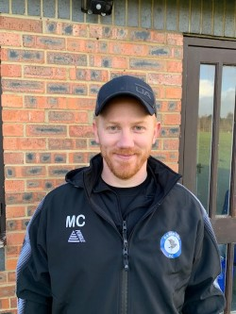 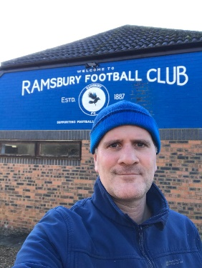 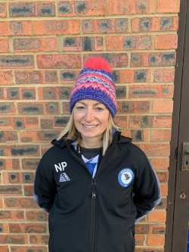 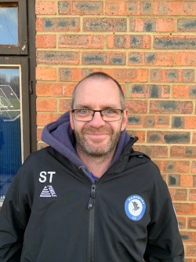 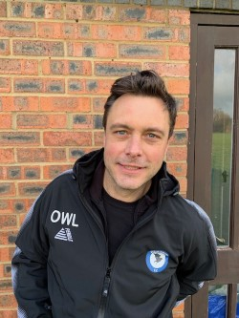

**DO YOU KNOW YOUR TEAM COACHES OR CLUB OFFICIALS?** 

**Under 6s Team Coaches**: Al MacKay (FA Playmaker), Ned Llewellyn and Alisdair Collis

**Under 7s Team Coaches**: Chris Allen (Level 1 Coach), Steve Taylor (FA Playmaker), J-P Degouve de Nuncques and Daniel Sully

**Under 8s Team Coaches**: Chris Allen (Level 1 Coach), Bash Miah (FA Playmaker), Nicky Place (FA Playmaker), Rob Green (FA Playmaker), Dougal Watts, Rupert Harrison, Matt Ilott, Alisdair Wade and Robert Dallas

**Under 9s Team Coaches**: Dan Beck (Level 1 Coach) and Matt Crame (FA Playmaker)

**Under 10s Team Coaches**: Olly Scott-Harden (FA Playmaker) and Simon Bartholomew (FA Playmaker)

**Under 11s Team Coaches**: Rich Gillard (Level 1 Coach), Adam Blanchford (FA Playmaker) and Mark Fisher

**Under 12s Team Coaches**: James Collister, Rob James (FA Playmaker) and Sonny Bathe (Level 1 Coach)

**Under 15s Team Coaches**: Mark Savory (Level 1 Coach), Oliver Bond (FA Playmaker) and Rich Englefield (Level 1 Coach)

**Under 16s Coaches**: Geoff Pratt (Level 1 Coach and GK Coach), Andy Knowles (FA Playmaker)

**Senior Team Coaches**: Sean Eviil and Chris Roberts (Level 1 Coach)

**Club Level 2 Coach**: James Underwood (Senior Team Player & Level 2 Coach)

**Club Chair**: Andy Knowles **Vice Chair**: Chris Roberts **Treasurer**: Bryony Beck **Secretary**: Jon Symon

**Club Welfare Officers (CWOs)**: Jon Symon & Chris Roberts **COVID Response Officer**: Jon Symon