

**RAMSBURY FOOTBALL CLUB NEWSLETTER **

Established 1887

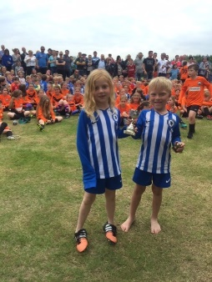**Dear Parents, Guardians and all involved with Ramsbury Football Club,**

**Firstly,** I would like to wish you and your families a happy Christmas and New Year! I hope you all get some time together over the festive period and have a well-earned break.

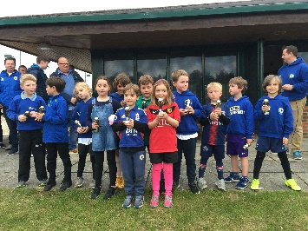**Secondly,** I am sure you have noticed the changes to our Clubhouse courtesy of our fantastic sponsors, Ergo Facilities Management. We now have a fully functioning kitchen and a much nicer area to sit, relax and enjoy a cup of tea or coffee or even a bacon butty. The refurbishment has been long over-due and we are so grateful to Arthur and Karen Carrington and the whole of their team at ergo facilities management for doing such a brilliant job.

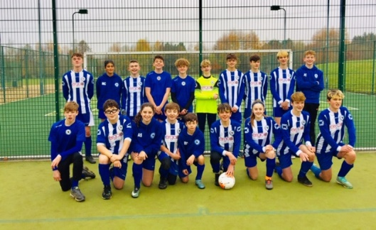**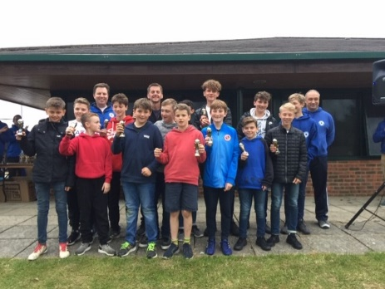Lastly,** our wonderful Football Club is only as good as it is because of you, the boys and girls who play in our 9 youth teams, those in the senior squad and the small band of volunteers who help train and coach the teams and manage the Club’s affairs. Without you we would not have the admiration, respect and dare I say the envy of other bigger clubs who praise our facilities, our teams, our ethos and how we play. As such, it has been no surprise that Ramsbury teams have been awarded the Fair Play Trophy for last three seasons by the League, with Rich Gillard and the U10s the recipients this year, have attained FA Chartered Standard status, were victorious (again) against MYFC in the annual RAMMAR Cup, had our teams win promotion, tournaments and respective cup competitions in addition to the Club hosting Swindon Town Football Camps, Futsal nights and successful trips to Swindon Town FC, Reading FC and Wembley! It has been an action packed year and with your continued support, help and involvement I am sure it will continue to be so. Here’s to you all and an equally fun filled 2020!

**Jon Symon**

**Chair**

 **WE NEED YOU TO SUPPORT YOUR FOOTBALL CLUB** 

**Volunteers are needed to help in the Clubhouse Café on Saturday or Sunday mornings and if you or your friends or family are able to help please pop into see Nicola or contact her at** [**Nicola.hickford@yahoo.co.uk**](mailto:Nicola.hickford@yahoo.co.uk)

**Each youth team requires a qualified coach to be able to play in the FA sponsored Leagues. Ramsbury FC will cover all costs for those parents or guardians who want to qualify to be a Coach – Contact Jon Symon or Chris Allen:** [**jonathansymon@hotmail.com**](mailto:jonathansymon@hotmail.com) **or** [**chris.allenqq@gmail.com**](mailto:chris.allenqq@gmail.com) **It would be great to have you as one of our Coaches!**

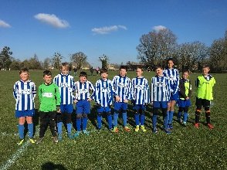 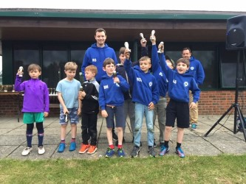  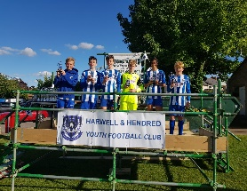 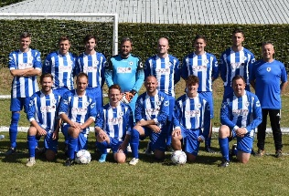

**DO YOU KNOW YOUR TEAM COACHES OR CLUB OFFICIALS?** 

**Under 6s Team Coaches**: Al MacKay & Pete Wheeler (Jon Symon Level 1 Coach)

**Under 7s Team Coaches**: Chris Allen (Level 1 Coach) and Jason Haythornwaite (Level 1 Coach)

**Under 8s Team Coaches**: Dan Beck (Level 1 Coach) and Jack (Qualified Young Referee (YR))

**Under 9s Team Coaches**: Martin Greenaway (Level 1 Coach), Ed Williams and Ben Jackson

**Under 10s Team Coaches**: Rich Gillard (Level 1 Coach)

**Under 11s Team Coaches**: James Collister and Sonny Bathe (Level 1 Coach)

**Under 14s Team Coaches**: Mark Savory (Level 1 Coach) and Oliver Bond

**Under 15s Coaches**: Geoff Pratt (Level 1 Coach) and Andy Knowles

**Under 16s Coaches**: Chris Allen (Level 1 Coach) and Jason Haythornwaite (Level 1 Coach)

**Senior Team Coaches**: Sean Eviil and Chris Roberts

**Club Chair**: Jon Symon **Vice Chair**: Chris Roberts **Treasurer**: Chris Allen **Secretary**: Nicola Hickford

**Have a look at our new web site:** [http://www.ramsburyfc.co.uk/](https://nam12.safelinks.protection.outlook.com/?url=http%3A%2F%2Fwww.ramsburyfc.co.uk%2F&data=02%7C01%7C%7C2162935440874f4a161408d74c0eb1d9%7C84df9e7fe9f640afb435aaaaaaaaaaaa%7C1%7C0%7C637061498303983689&sdata=O7beFgq7dQJaCyVSgVbZAzLiHCwTrPypW%2F4b%2FFut4lg%3D&reserved=0)

**DO YOU KNOW YOUR CLUB WELFARE OFFICERS?** 

Nicola Hickford and Chris Roberts are your Club Welfare Officers with Jon Symon replacing Nicola when she sadly departs the Club in 2020.

**Safeguarding** children and young players within Ramsbury FC remains paramount and all qualified Coaches are both First Aid and Safeguarding trained. This is mandated by the FA and critical for attaining Chartered Standard status. PLEASE do feel free to discuss any issues you may have concerning safety or safeguarding with your coaches or one of the Club Welfare Officers. Ramsbury FC also has policies on Child Protection and Code of Conduct that can be found at our website: [http://www.ramsburyfc.co.uk/](https://nam12.safelinks.protection.outlook.com/?url=http%3A%2F%2Fwww.ramsburyfc.co.uk%2F&data=02%7C01%7C%7C2162935440874f4a161408d74c0eb1d9%7C84df9e7fe9f640afb435aaaaaaaaaaaa%7C1%7C0%7C637061498303983689&sdata=O7beFgq7dQJaCyVSgVbZAzLiHCwTrPypW%2F4b%2FFut4lg%3D&reserved=0)

The FA also want all Clubs to make you aware that any adult or young person with urgent concerns can also ‘whistle-blow’ by calling 0800 169 1863 and asking for The FA safeguarding team, or via email on [safeguarding@TheFA.com](mailto:safeguarding@TheFA.com). Alternatively you can go direct the Police or Children’s Social Care and report your concerns there, or to the Child Protection in Sport Unit via [cpsu@nspcc.org.uk](mailto:cpsu@nspcc.org.uk) or the NSPCC Helpline via 0808 800 5000 or by emailing [help@nspcc.org.uk](mailto:help@nspcc.org.uk).

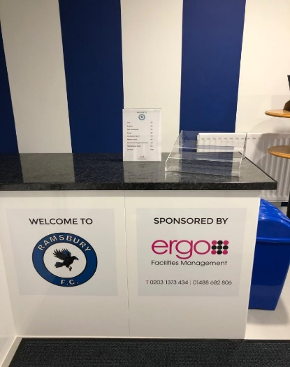**Ramsbury FC Clubhouse Refurbishment**

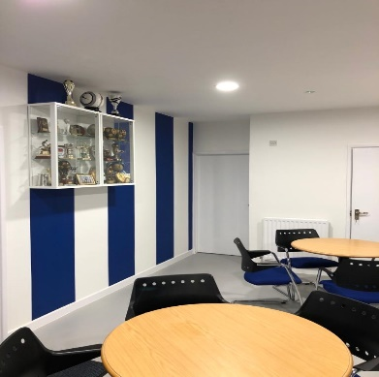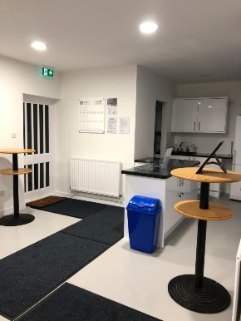Hopefully you will all have visited Nicola in the Clubhouse to get a coffee or tea or a bacon butty on a Saturday or Sunday morning and if so you will have seen the stunning refurbishment courtesy of our club sponsor Ergo Facilities Management.

The difference it has made to the Club has been amazing and it has certainly made it more welcoming, a much nicer place to get out of the wind and the rain when the weather has been poor (too often unfortunately!).

There is more to come as Ramsbury FC plan to repair the infrastructure and update the back of house, especially the toilets and changing rooms, provide an information notice board, provide information and pictures of all Coaches and their contact details and, finally, recondition and put up a number of historic pictures of Ramsbury FC teams from years gone by. Our aim is to ensure the Clubhouse is as good as it can be for you all.

**Match Day Experience at Reading FC**

About 25 Ramsbury FC U14s and U13s players had a superb match day experience at Reading Football Club where they had excellent seats to see the Royals defeat Nottingham Forrest in a hugely entertaining game.

The U14s players also took penalties at half time; had their team photo in the match day programme and met the Mascot before being given a goody bag to take home. It was great fun and another visit is planned for 25 January 2020: Reading FC v Bristol City FC.

**Waitrose Presents Community Matters Cheque**

Andy Knowles, Ramsbury FC U15s Coach, with his son Fred and Team Captain Ben Pratt receive a cheque for £112.00 from Waitrose Marlborough as part of the Community Matters scheme.

It was a generous donation from the Community and will go towards buying foam rollers and belts as part of the Club’s initiative with **Frankie Naylor Sports Therapy** to improve overall fitness and reduce injury. Frankie has a son playing in the U6s team and has been advising teams on Saturday mornings during training sessions and we are delighted that she has agreed to do so again for 2020. The rollers and belts are her recommendation and will be a great help. Again, more great support from within our community!

