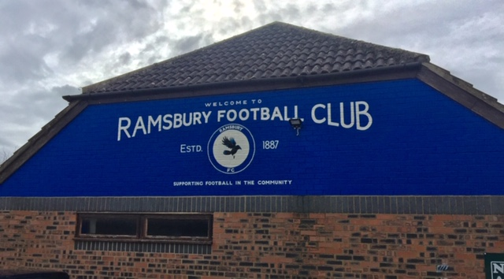

MESSAGE FROM RAMSBURY FOOTBALL CLUB

You will be fully aware of the measures in place to combat the COVID 19 pandemic and the need to adhere to Government direction to reduce the spread of infection in order to save lives. This has included the need for us all to stay at home as much as we can and minimise travel, increase hand washing and sanitisation and adopt ‘social distancing’ when we are outside. It has also meant a significant restriction on social gatherings, unless absolutely necessary, and resulted in the Football Association (FA) to stop all ‘grass roots’ football:

'Furthermore, we can now confirm that we have decided that all grassroots football is concluded for the 2019-20 season. This will allow the game to move forward and to commence planning for next season.
https://www.bbc.co.uk/sport/football/52052351

This was sad news for all those who love their football, but very understandable considering the grave situation faced. Ramsbury Football Club has fully supported the decisions made by the Government and has also adhered to FA direction by stopping all training and matches and prematurely ending the 2019/2020 season.

What Does This Mean?

- Firstly, it means no matches or training can take place at the Ramsbury Recreation Ground until we are authorised to do so. For all teams this has resulted in a shortened season as the 2019/2020 season has concluded.
- Secondly, it is very likely that all teams will not be relegated or promoted this season and cup matches will only be played when it is safe to do so.
- Thirdly, Ramsbury FC still plan to hold our end of season Awards Ceremony, but this will likely be later than the planned date we had earmarked at the end of May. A confirmed date will follow when appropriate as the Club remains keen to ensure all players are recognised for everything they have achieved. It will include trophies for all registered players, individual awards and a range of fun football activities. We are also hopeful that the RAMMAR Cup 2020 will also go ahead, but will need to agree this with MYFC.
- Lastly, Ramsbury FC will reduce subscriptions for existing members for next season. This will apply to all those who paid full subs for 2019/20 and who sign up for the 2020/21 season and take the opportunity to pay their subscription early by 30 September 2020. Those who do so will receive discounted rates of £25 for U6s and seniors and £60 for U7-16s. For new joiners and those paying after 30 September then full subscriptions will remain unchanged at £45 for U6s, £50 for seniors and £95 for U7-16s respectively.

What Next?

We will all have to wait and see when training can resume and also what the FA decide regarding leagues, cup matches and next season. The Club will let you know as soon as we are informed. In the interim, and at an appropriate time, the Club will send out the 2020/2021 Season registration forms to Coaches to disseminate or to be directly accessed from the Club web site. We will also let you know when we will hold our end of season Awards Ceremony, what format that will take and what categories of awards there will be. As far as I am aware all Coaches are keen to continue next season and the plan will be to prepare in order to be ready for when we can return to some sort of normality. The Club, alongside our sponsor Ergo Facilities Management, remains committed to investing in our players and coaches, our infrastructure, equipment and facilities and, importantly, in ensuring that football in our community remains fun, safe and enjoyable.

What Can You Do?

Until we do return to training and matches the priority must remain on you all staying safe and well and adhering to government direction to minimise risk to the most vulnerable in our community. I know the current situation will be very tough for many of you and especially those who have suffered loss of a loved one; are key ‘frontline’ workers or have been sick or unwell or are supporting those sick and unwell. Our thoughts are with you all.

Do try and stay safe (and sane) during this difficult time and I would encourage all players (and coaches) to keep up their fitness and skills as best they can. There are loads of tips online and here is one you can pass on to all age groups: https://youtu.be/SoijY4BUCtw.
Keep in touch with each other and your coaches and/or fellow players through your social networks or platforms or with the Club via our Ramsbury FC web site: http://www.ramsburyfc.co.uk.

If you have any questions or concerns then please do get in touch.

Jon

Jon Symon
Chair
Ramsbury Football Club
07802413246 http://www.ramsburyfc.co.uk

Please note that further direction remains awaited from the FA on leagues and cup matches.

